**CLICK AND BUY**

**Form design**

ADMIN AND MODERATOR

**FRONT PAGE**

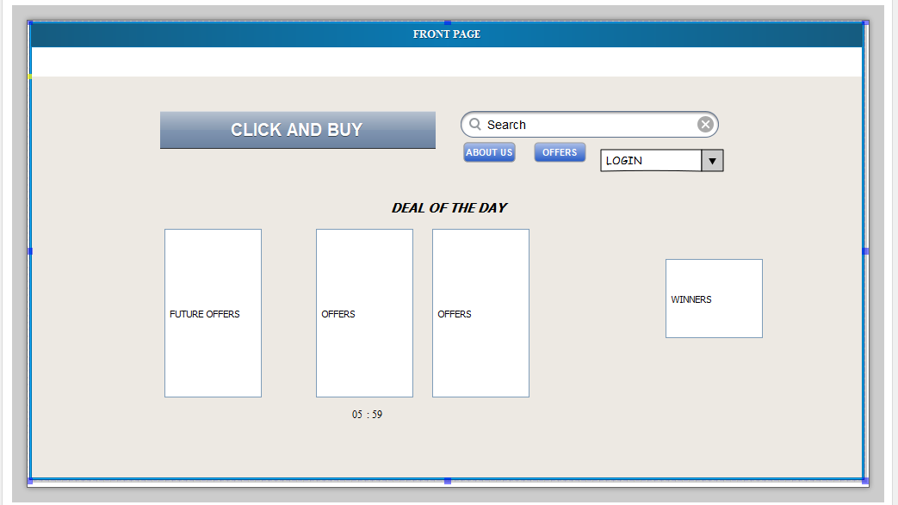

LOGIN AND ADMIN ADD JOBS

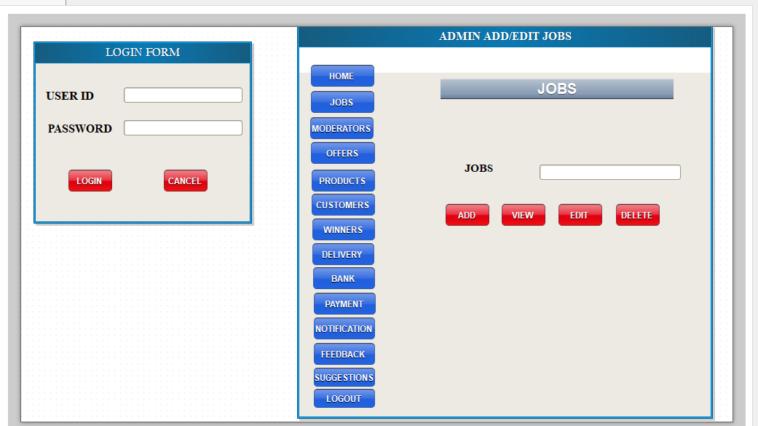

ADMIN ADD MODERATORS

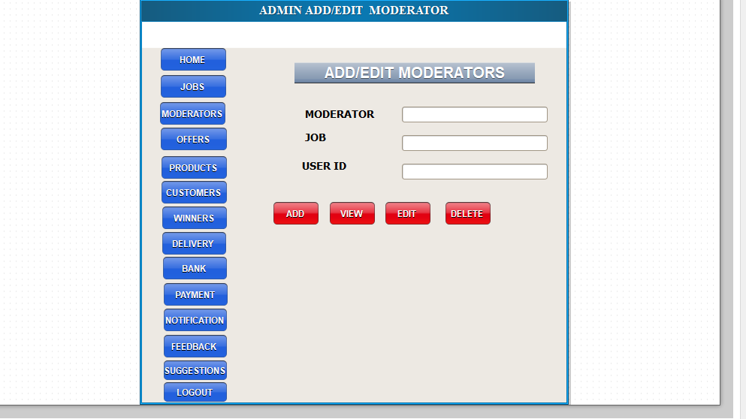

ADMIN ADD POINTS

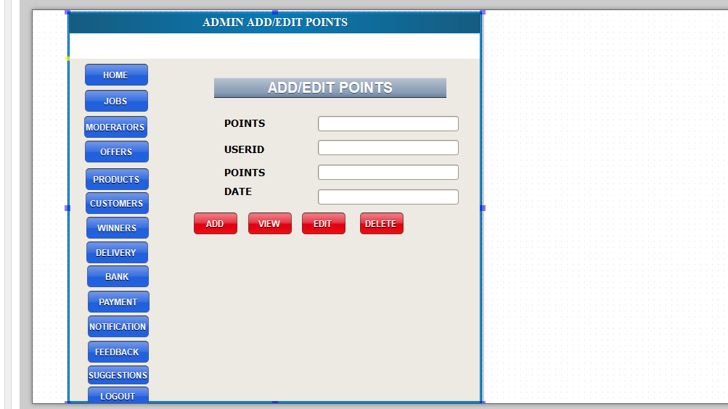

ADMIN ADD OFFERS

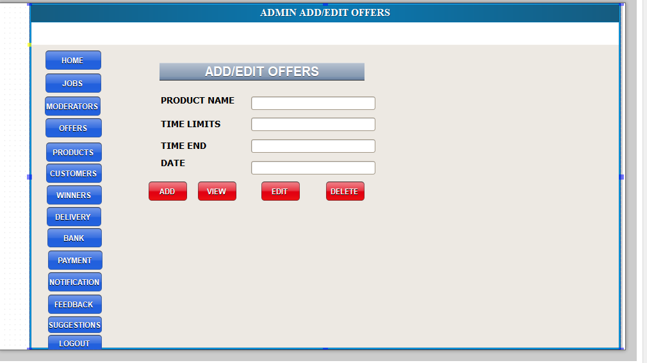

ADMIN ADD/EDIT PRODUCT DETAILS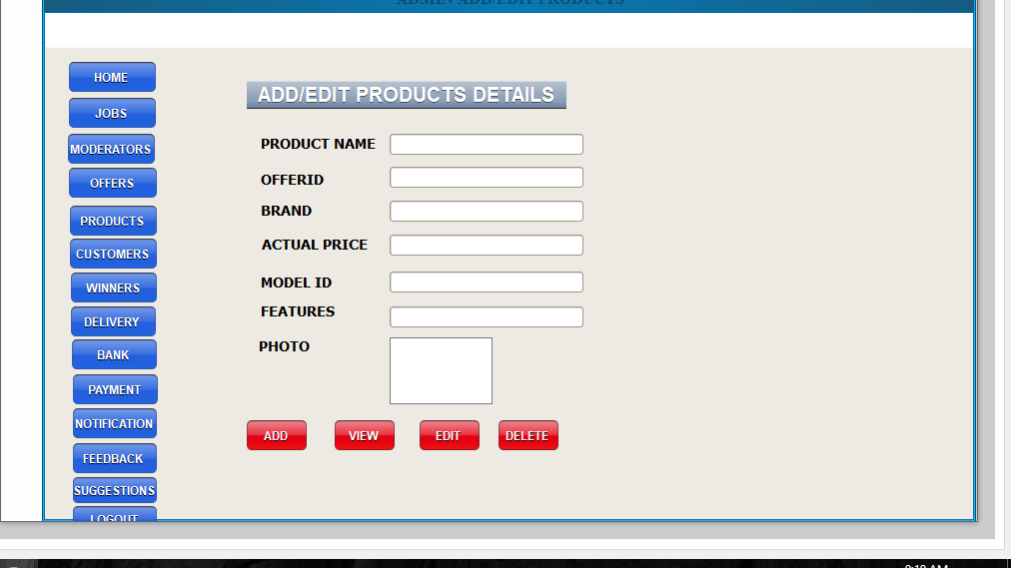

ADMIN VIEW CUSTOMERS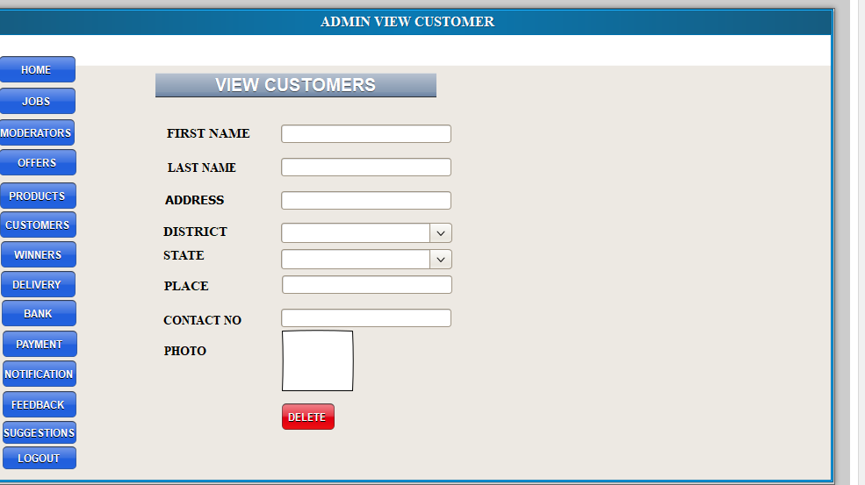

ADMIN ADD WINNERS

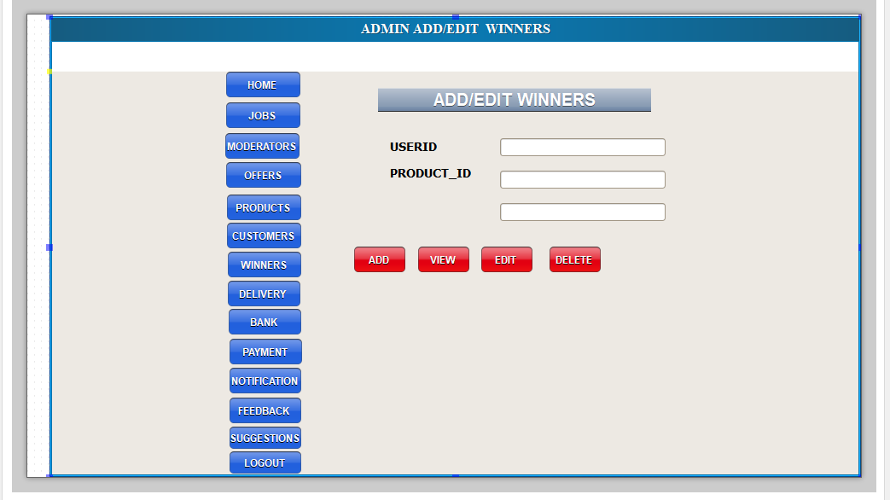

ADMIN ADD NOTIFICATION

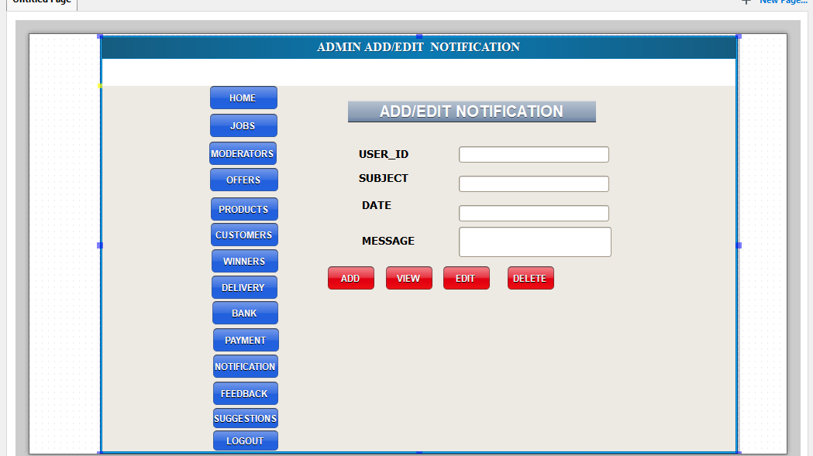

ADMIN ADD BANK DETAILS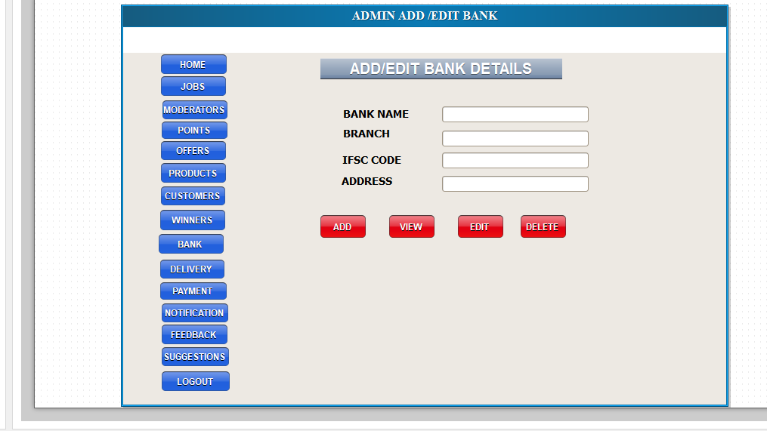

ADMIN VIEW PAYMENT

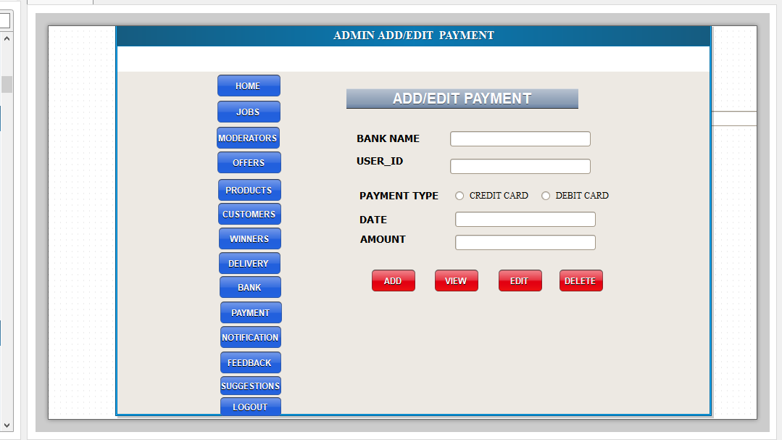

ADMIN ADD DELIVERY DETAILS

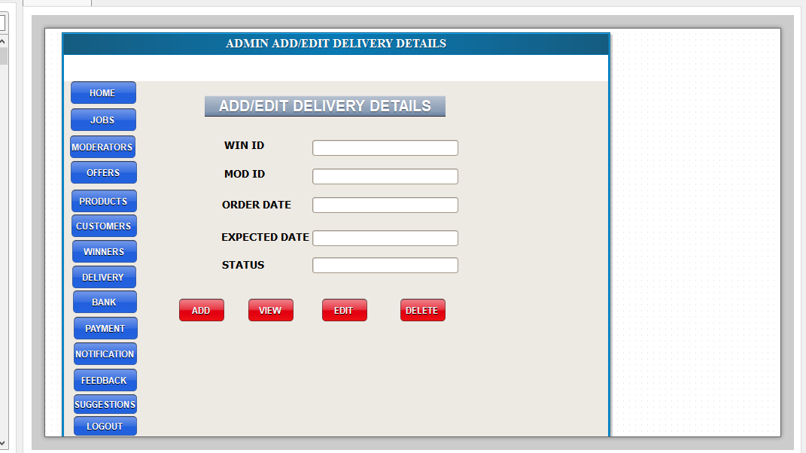

ADMIN VIEW FEEDBACK

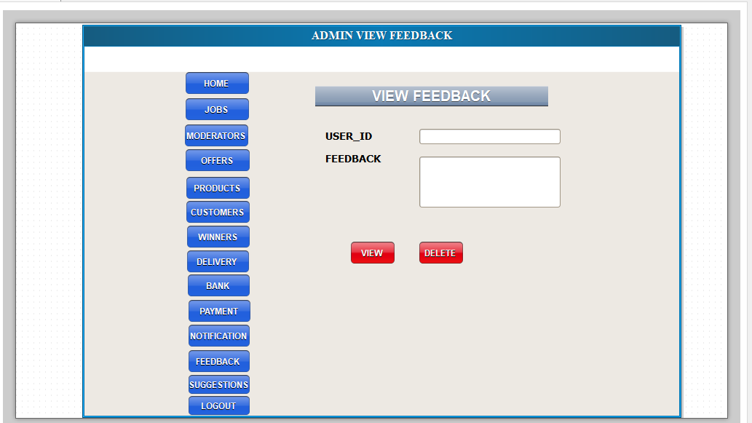

ADMIN VIEW SUGGESTIONS

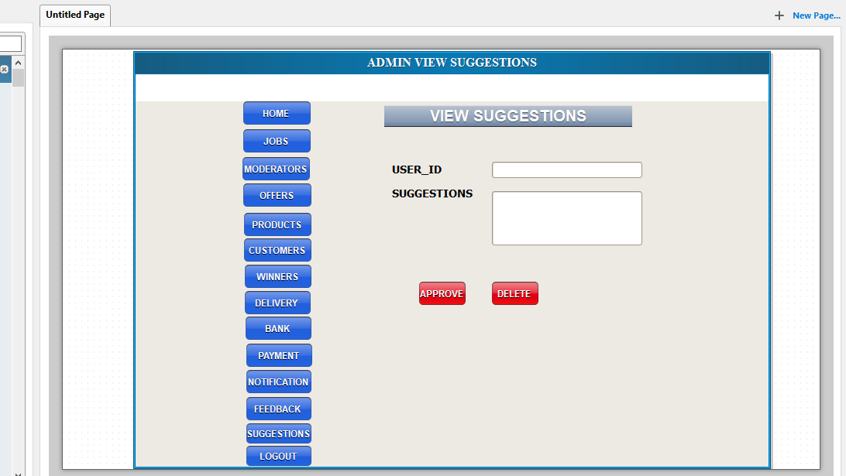

CUSTOMER REGISTRATION AND LOGIN

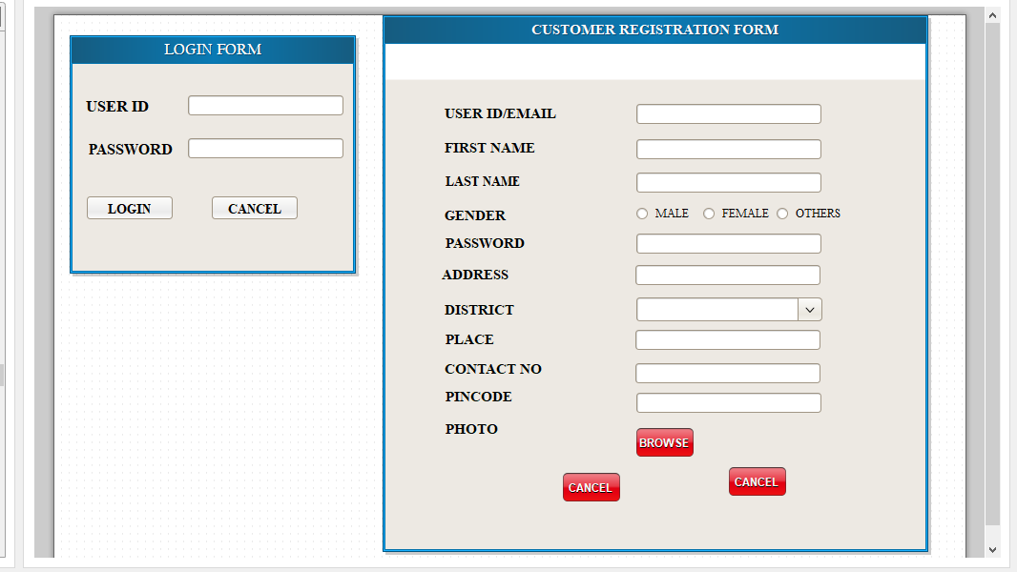

VIEW PROFILE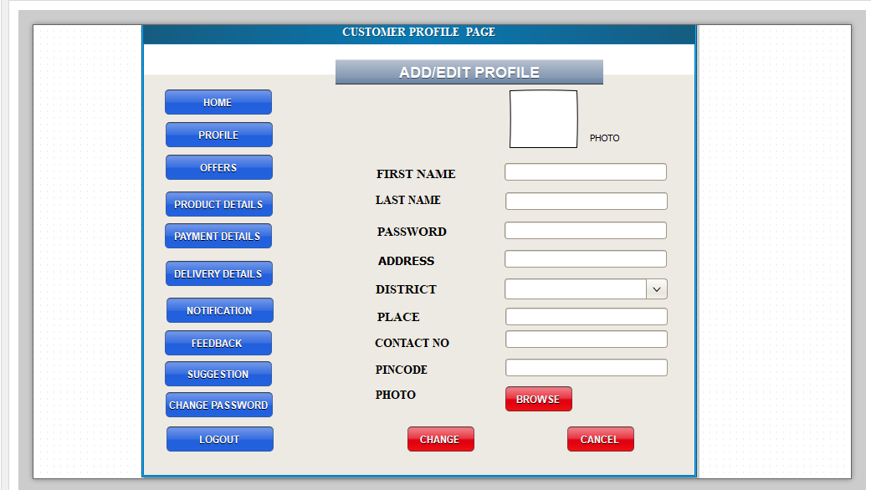

VIEW OFFERS

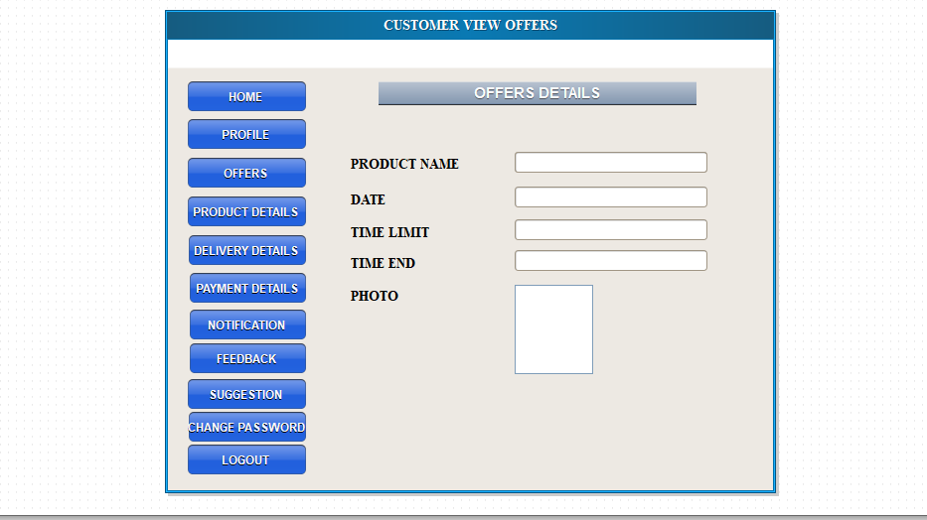

VIEW PRODUCTS DETAILS

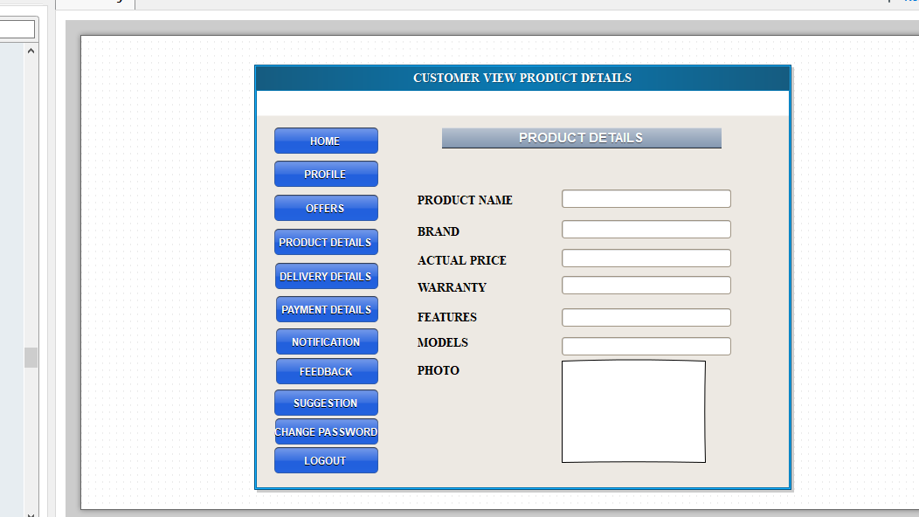

VIEW NOTIFICATION

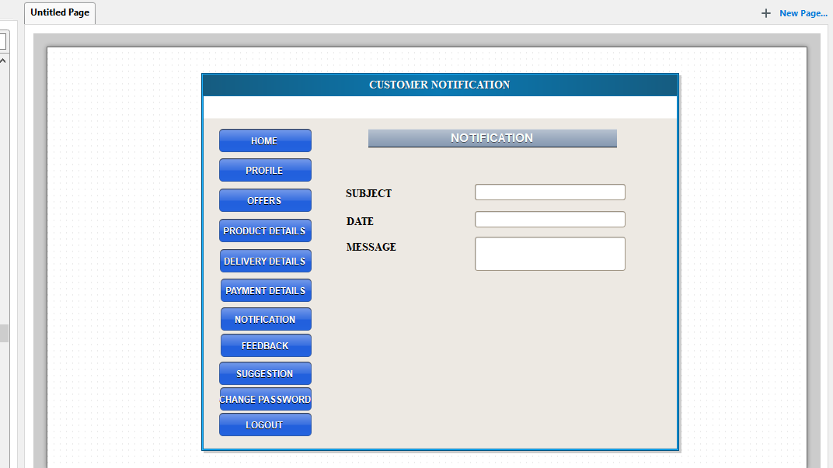

VIEW PAYMENT DETAILS

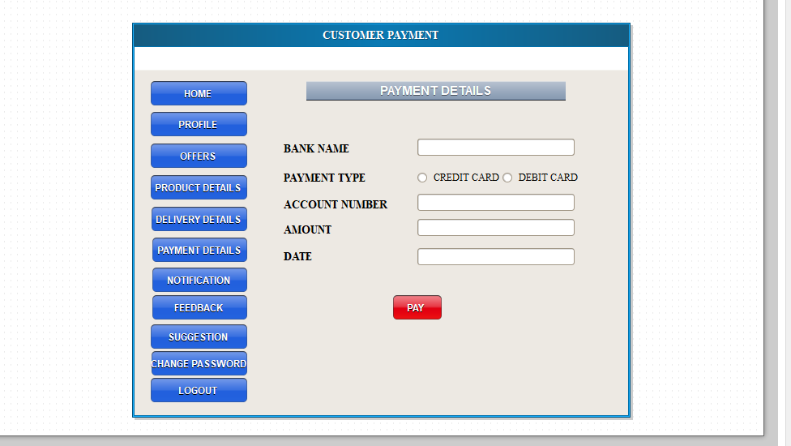

VIEW DELIVERY DETAILS

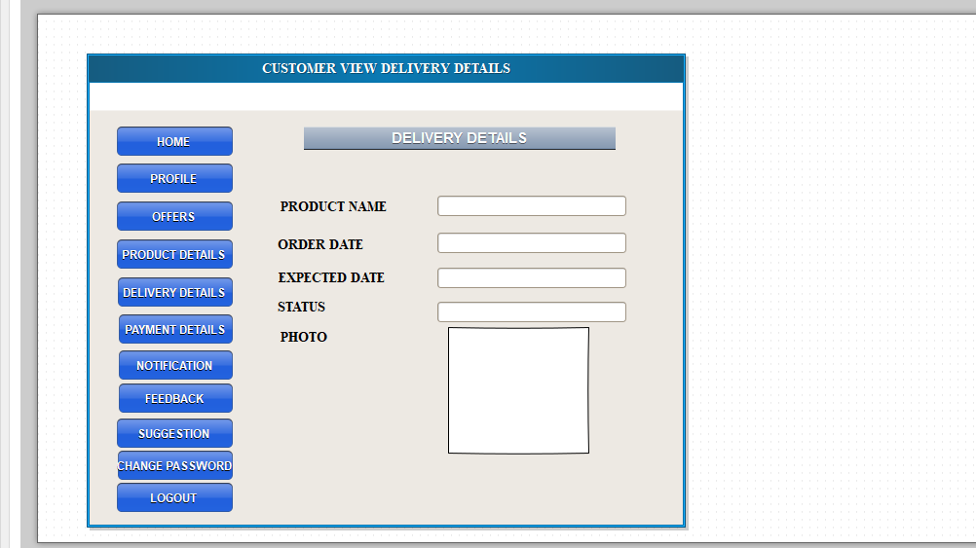

FEEDBACK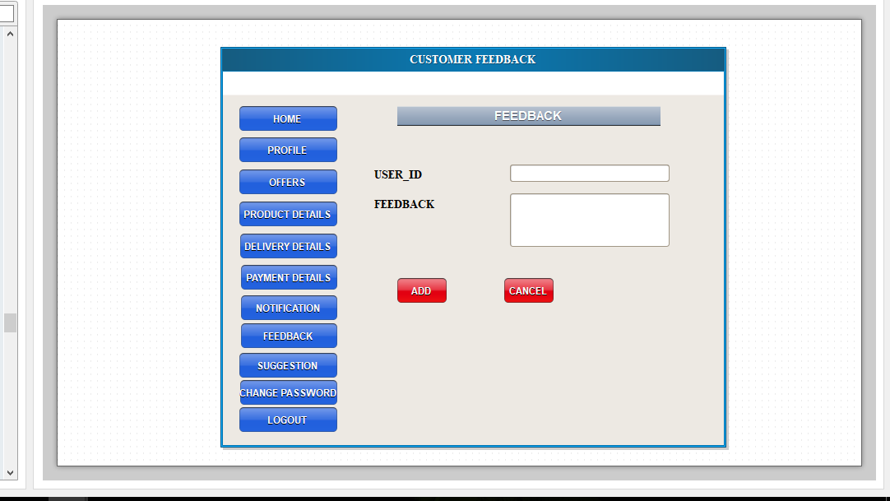

SUGGESTIONS

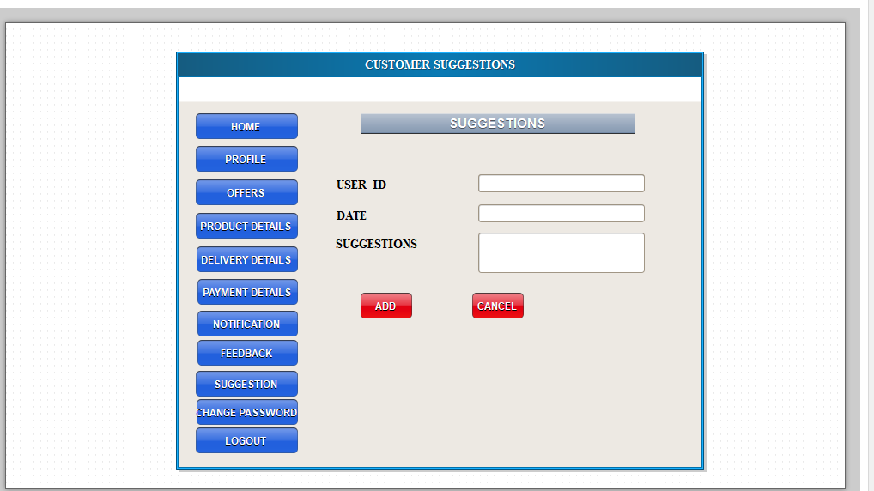

CHANGE PASSWORD

